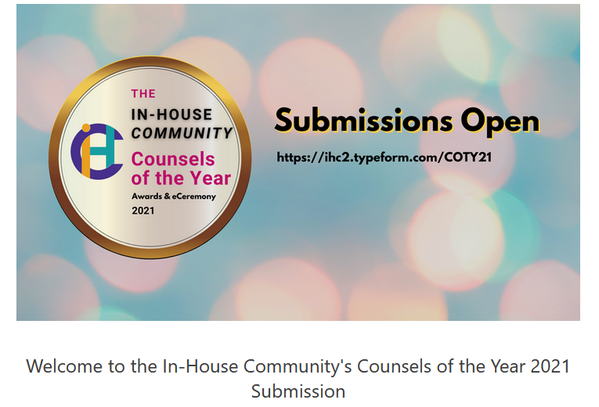
- Choose your industry - for Industry Awards.
You can only choose 1. Tick/circle the choice.

- Aviation
- Banking
- Conglomerate
- Energy & Natural Resources
- Financial Services (ex-Banking)
- Insurance
- Life Science & Pharma
- Manufacturing & Engineering
- Property, Infrastructure & Logistics
- Retail
- Technology, Media & Telecom
- Travel & Leisure
- Other: _______________________________________________________

- Choose Practice for Best Practice Management Awards.
You can choose up to 2 only. Tick/circle the choice.

- Change Management
- Compliance
- Corporate Social Responsibility
- Diversity
- Innovation
- Integration
- Small Team
- Technology Integration
- Transactional

- Your jurisdiction.
- Your First Name:
- Your Last Name:
- Name of your organisation:
- Your position/job title?
- Your official email ID?
- Name of the head of department
Please type 'self' if you are the head of department.
- Position/Job title of the head of department
- Email ID of the head of department

I would like to nominate:

My country team
My regional team
Myself / other individual

- Explain below why this counsel / team should win (more than 600 words), demonstrating as many of the following as you can: Dedication; Innovation; Efficiency & Value; Integration; Encouragement & Improvement; CSR & Diversity. You may attach a document to this form for this answer.

- If possible, please also provide an endorsement from a member of the board, business unit or senior director, or the contact details of one who would be willing to be contacted for such. Please write their full contact details including name, position, email ID and phone number.

For any further questions and to submit your responses and any supporting documents, please email:

Ms. Yvette Tan
Yvette.Tan@inhousecommunity.com

Submission Deadline: 8th November 2021.

