Deals of the Year, 2018 Plaque Booking Form

Firm name:

Contact Person:

Email:

Address:

Phone:

Deal of the Year Winner Plaques for your  Office/reception/meeting rooms.  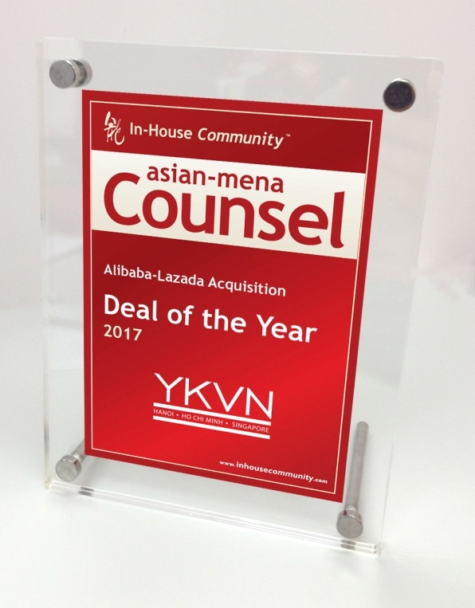 | Deal of the Year Winner - Congratulatory Plaques for your clients who worked on the deal  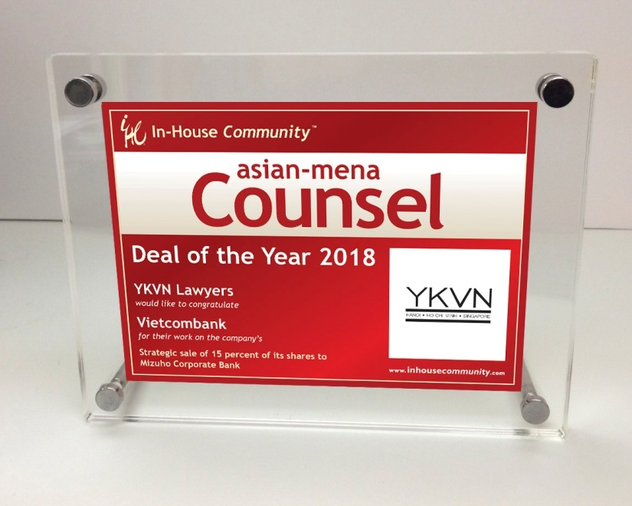

I wish to purchase ___ (number) 'Deals of the Year' Plaque(s).

I wish to purchase ___ (number) 'Congratulatory' Plaque(s).

Accepted by (authorised Signature): ____________________________________________

Dated: _______________________

TERMS AND CONDITIONS

- Payment to be made on receipt of invoice.
- The amount/s shown on this contract is that which should be received in full by Pacific Business Press Ltd upon payment. Any deductions, bank charges or other, are the responsibility of the invoiced party.
- Hong Kong Law applies to any interpretation of this agreement.

PLEASE RETURN BY FAX TO: 852 2575 0004 or by email to sender

